**Assignment No. 8**

**DEPLOY A PROJECT FROM LOCAL MACHINE TO GITHUB AND VICE-VERSA**

**Give a Repository name and set it as private.Then click on “Create repository”.**

**Visit github.com,login in it and the click on “New repository”.**

**1.….**.

**2.**

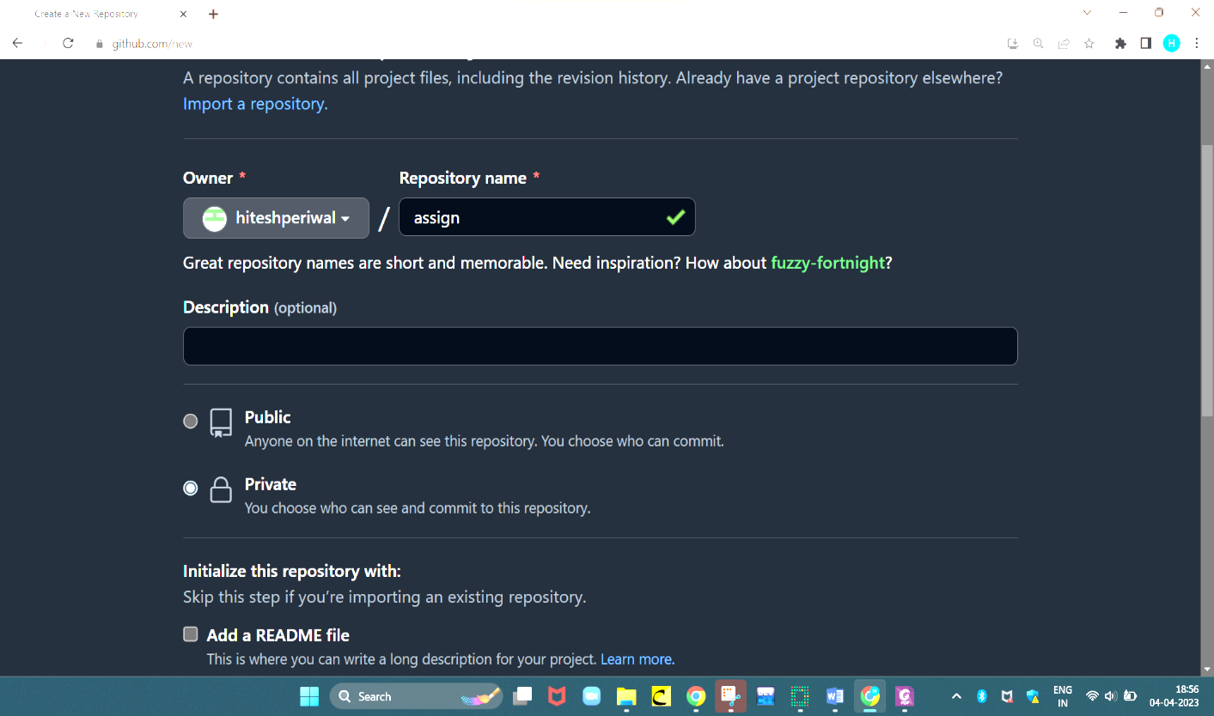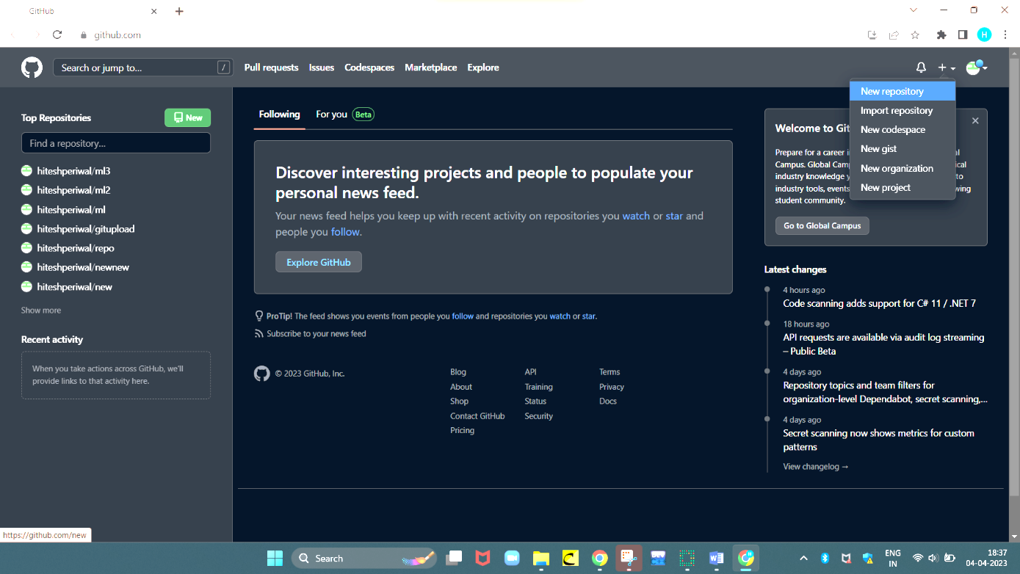

**Go to Settings,on the bottom of the left panel click on “developer settings”.Then go to “Personal access tokens” ,choose “Tokens(classic)”.Now on the right side select “Generate new token” and then “Generate new token(classic).**

**3.**

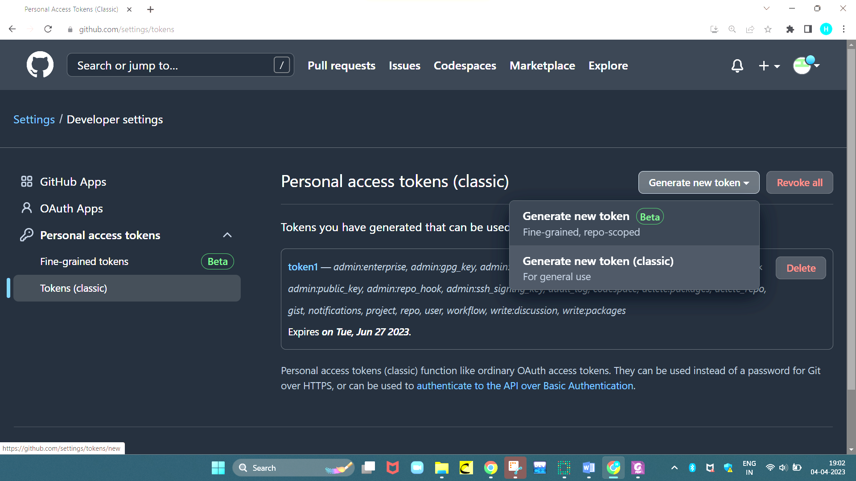

**Now give this token a name,select expiration duration as 90 days.Click on all the checkbox listed under scopes to get the full control.Then click on “Generate token”.**

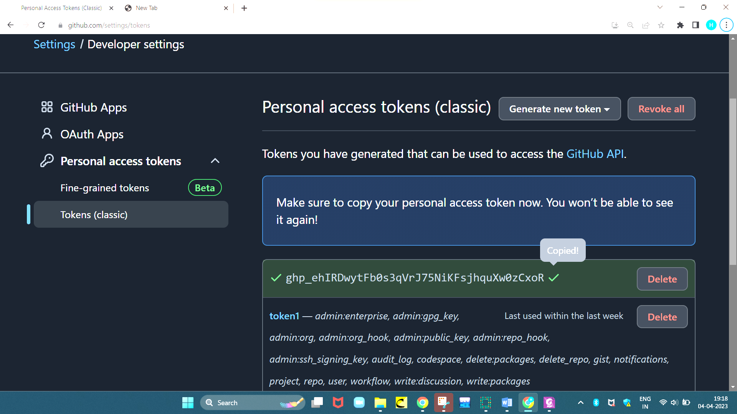

**Copy and save the generated token for future use.**

**4.….**.

**5.**

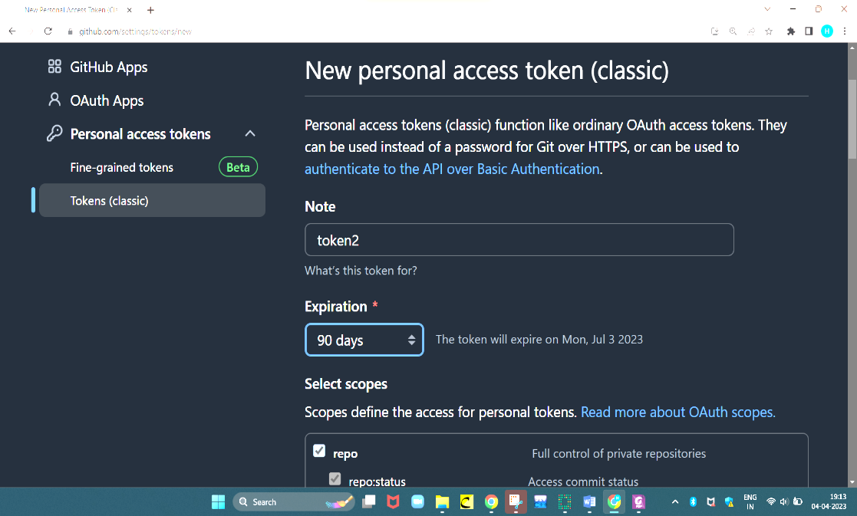

**Go to settings option inside “assign” repository.Click on “Collaborators” and “add people” with whom you want to collab this project.Invitation can be sent to the respective person using the github username or email id with which his/her github account is associated.The invitation can be accepted using the link that the person will receive on the registered email or by navigating to the notification section of his/her github account.Upon acceptance of the invitation , the private repository will be accessible to that collaborator.**

**6.….**.

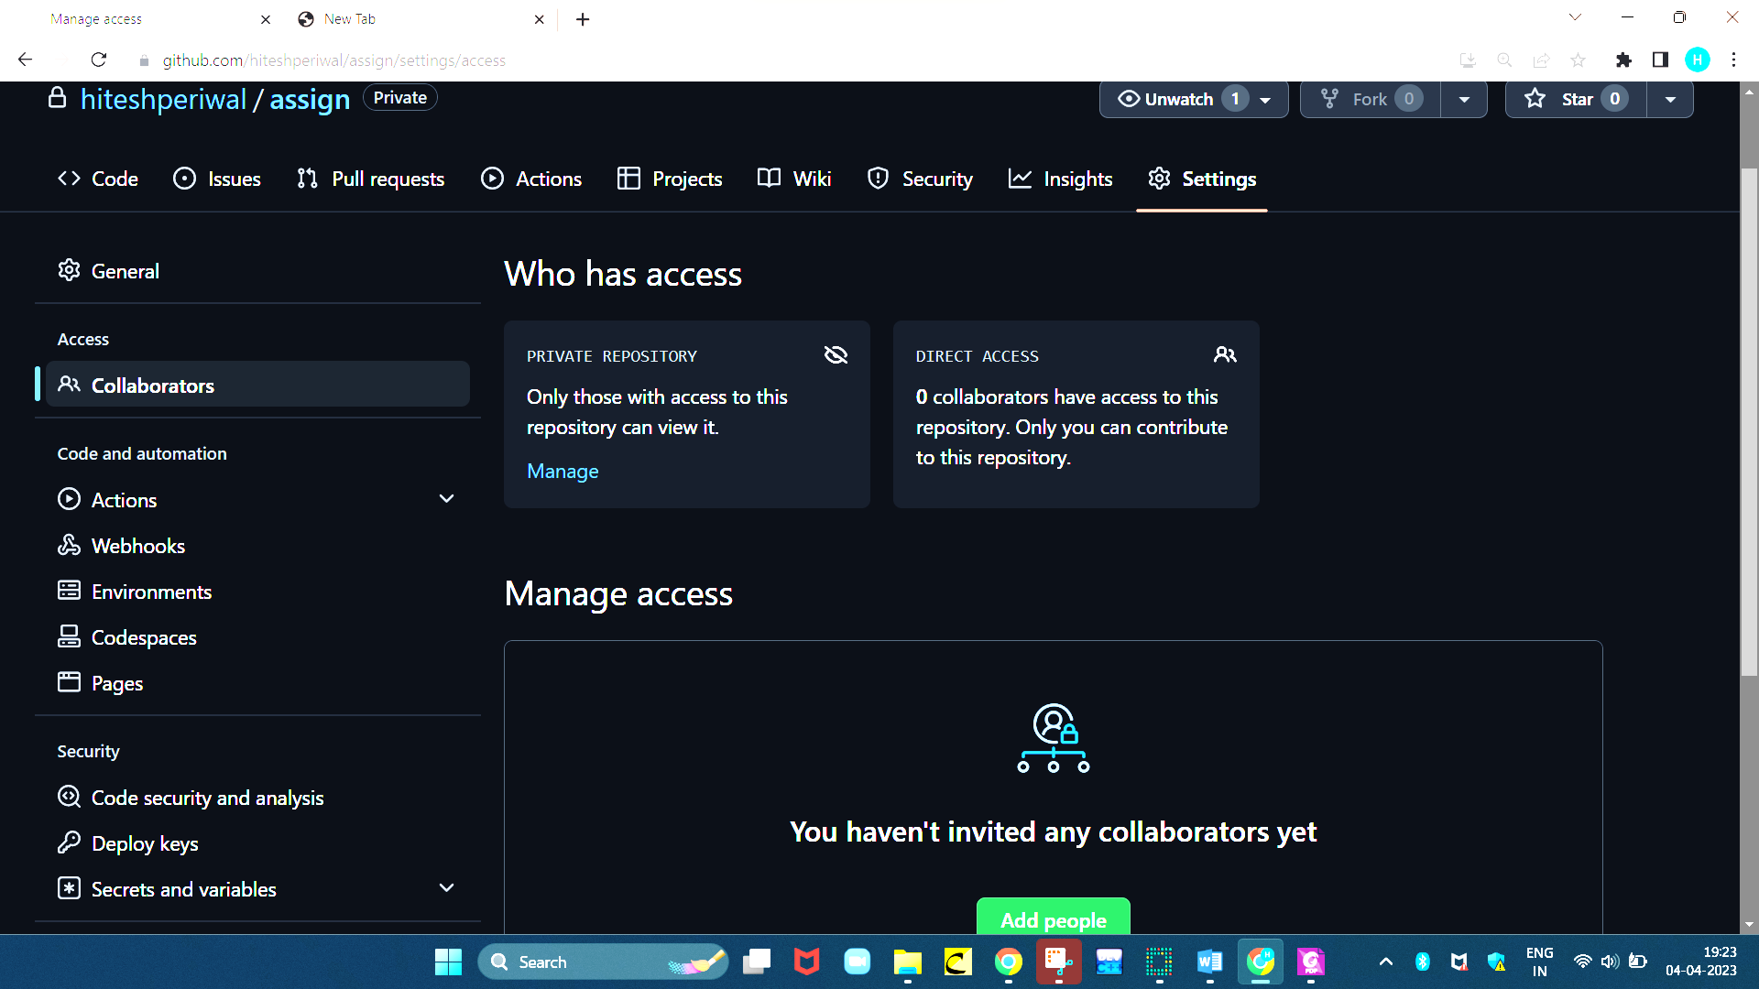

**S**

**Copy the https link of the repository which will be required in the upcoming steps.**

**8.**

**Right click on the folder whose file you wish to deploy on github and click on “Git Bash here”.**

**7.**

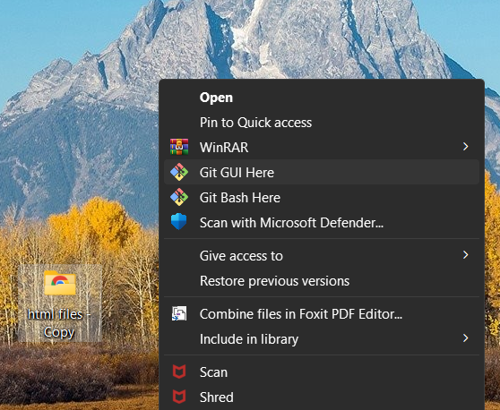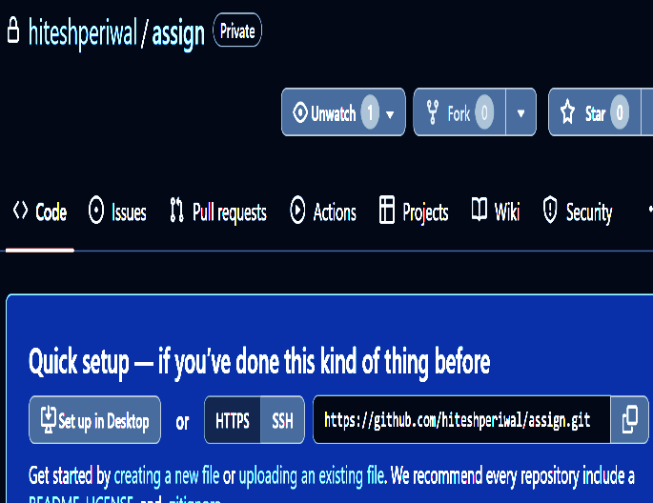

**9.**

**Type the following commands in the git bash to deploy a project from local machine to Github**

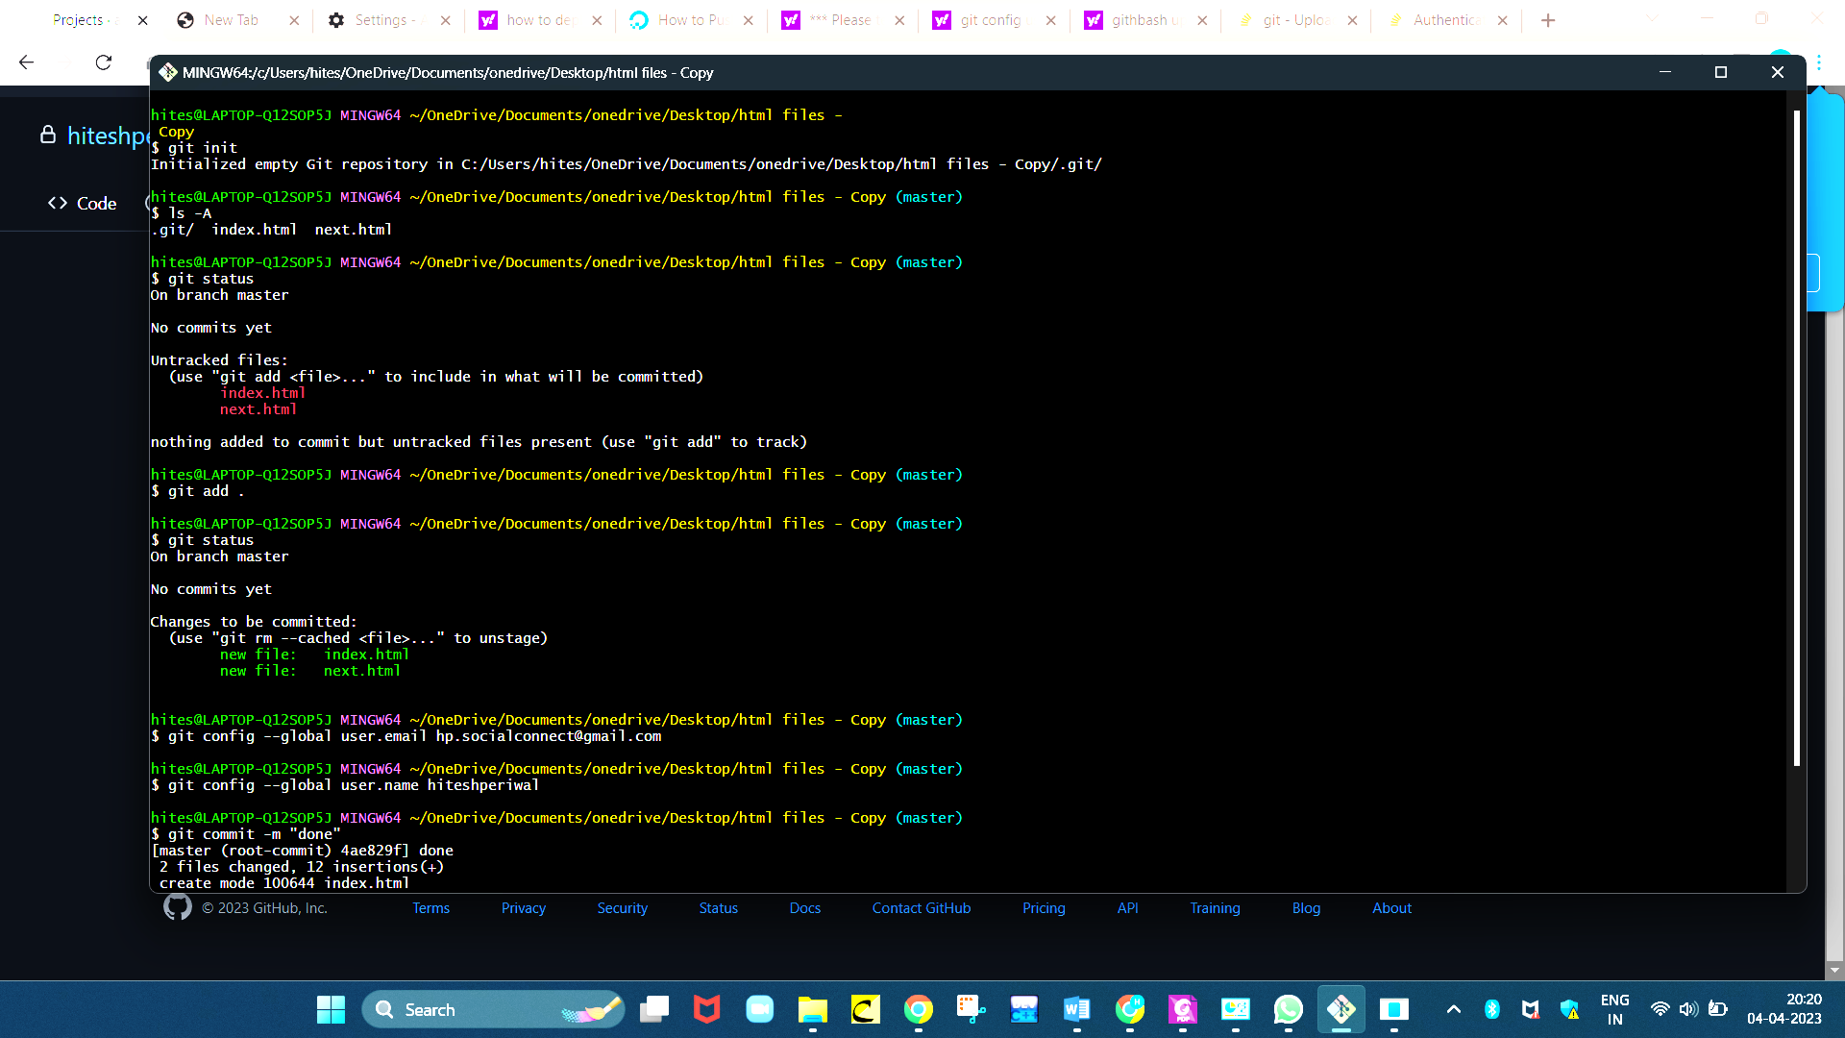



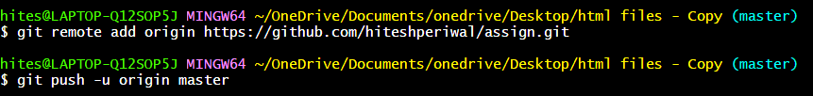

**10.**

**The project is thus deployed from local machine to github”.**

**11.**

**In the window which poped up,select sign in using token,paste the token saved previously and click “Sign in”.**

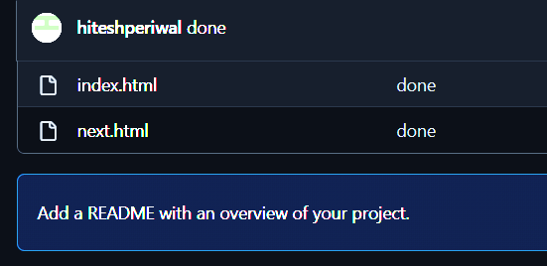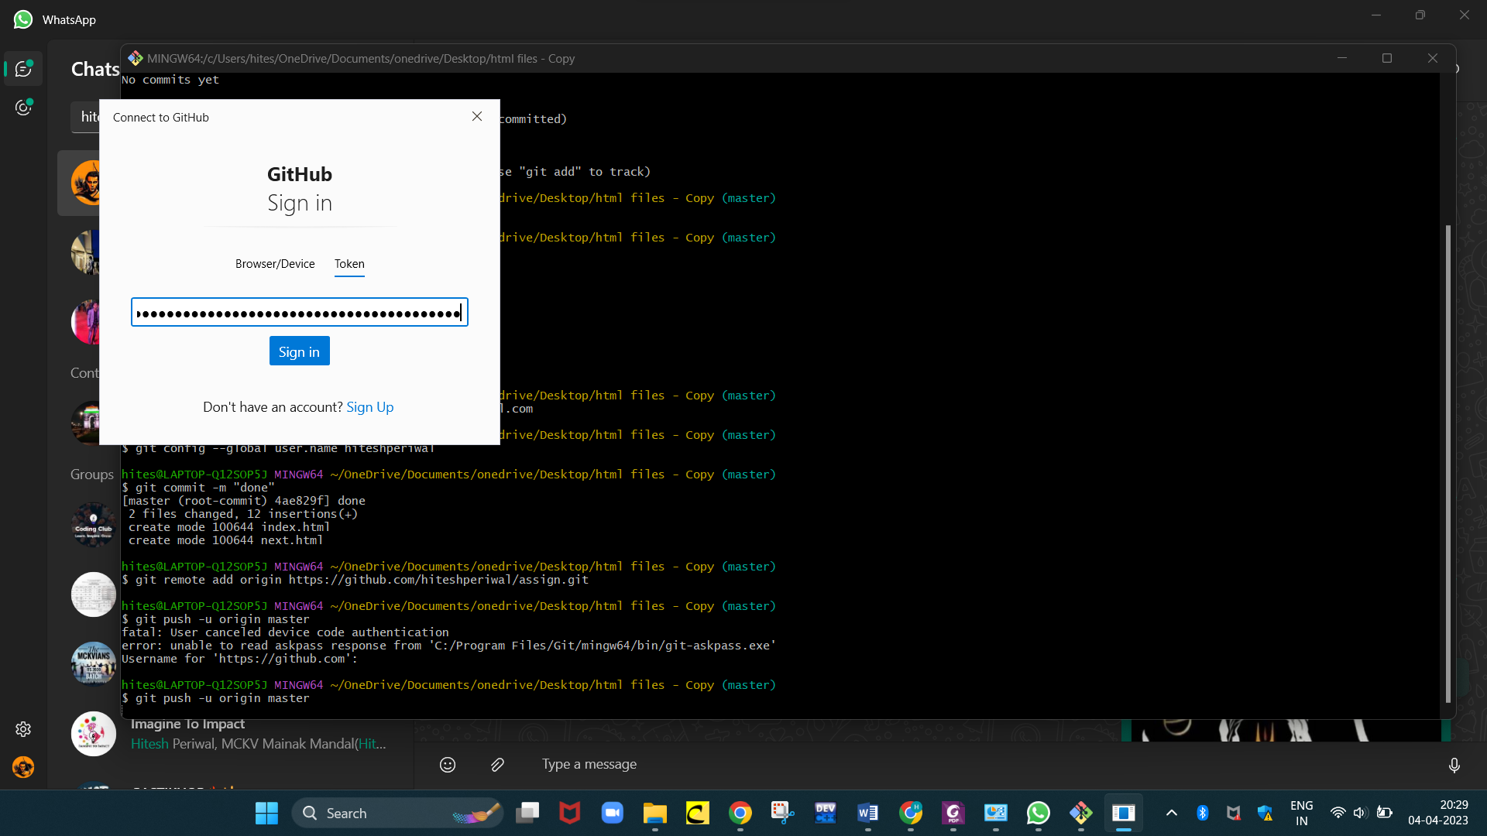

**12.**

**To deploy a project from Github to local machine :-**

**a. Copy the link of the repository which you want to deploy.**

**b. Create a new folder named “N1” and open gitbash there.**

**c. Type the following commands in the git bash (use the link of the repository in the command).**

**d. Thus,the task is complete**

